**Lab Assignment 6**

**Name – Abhijit Gawai**

**Roll no – 18 (Batch 1)**

**Gr no – 11810895**

**Problem Statement :** Write a useful and relevant PL/SQL trigger and cursor for your DBMS application.

INITIAL DATABASE:

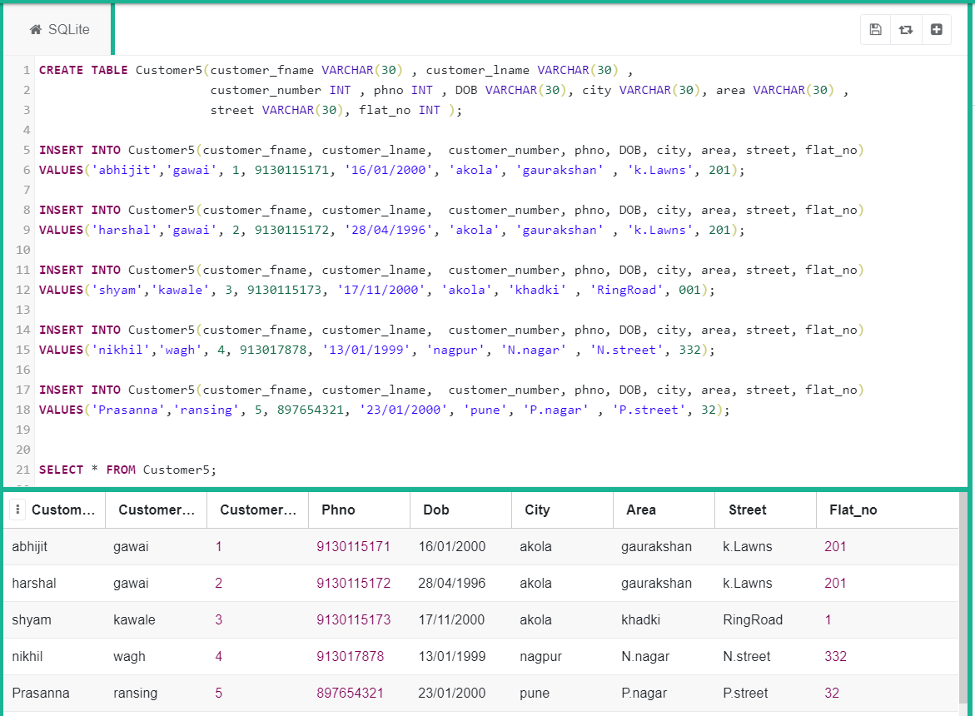

TRIGGERS:

Insertion

**Query:**

create trigger newtrig1

before INSERT

on

Customer5

for each row

begin

DBMS_OUTPUT.PUT_LINE('You just inserted a new record');

end;

/

insert into Customer5(customer_fname, customer_lname, customer_number, phno, DOB, city, area, street, flat_no)

values('Swayam','Deshmukh', 6, 917654321, '03/08/2004', 'Akola', A.nagar' , 'A.street', 203);

**OUTPUT:**

You just inserted a new record

1 row(s) inserted.

Updation

**Query:**

create trigger newtrig2

after update

on

Customers

for each row

begin

DBMS_OUTPUT.PUT_LINE('You just updated a record');

end;

/

Update Customer5 set flat_no = 312 where flat_no = 32;

**OUTPUT:**

1 row(s) updated

You just updated a record.

CURSORS:

**Query:**

DECLARE

CURSOR cursor_for_db IS

SELECT cities FROM Customer5;

BEGIN

FOR cities IN cursor_for_db

LOOP

Dbms_output.put_line('City name is : '||Customer5.city);

END LOOP;

END;

**OUTPUT:**

City name is : akola

City name is : akola

City name is : akola

City name is : nagpur

City name is : pune

**Query:**

DECLARE

    @customer_fname VARCHAR(MAX),

    @customer_lname   VARCHAR(MAX;

DECLARE full_name CURSOR

FOR SELECT

        customer_fname,

        customer_lname

    FROM

        Customer5;

OPEN full_name;

FETCH NEXT FROM full_name INTO

    @customer_fname,

    @customer_lname;

WHILE @@FETCH_STATUS = 0

    BEGIN

        PRINT @customer_fname + CAST(@customer_lnam);

        FETCH NEXT FROM full_name INTO

            @customer_fname,

            @customer_lname;

    END;

CLOSE full_name;

DEALLOCATE full_name;

**OUTPUT:**

abhijit – gawai

harshal – gawai

shyam – kawale

nikhil – wagh

Prasanna - ransing